October 2024 Zoom Link for
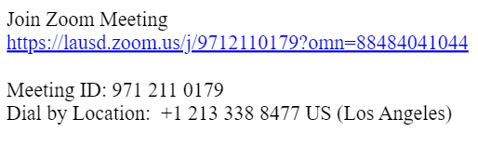
ELAC Meeting, SSC Meeting,

and Annual TITLE 1 Meeting

